Artifact – Old Rotary Phone
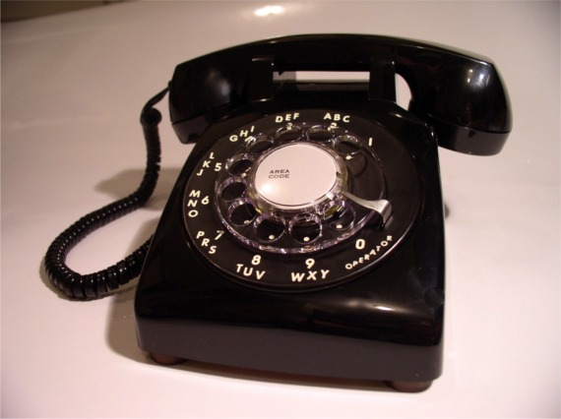
The object is solid black in color, made of some type of plastic. It is not too heavy, but appears to be solid. This whole artifact is made up of two parts. There is a large base, which has a rotary dial. Connected via a long coiled wire, there is a a longer piece. This piece has two round ends, with a narrow bridge connecting the two ends.
Since this artifact is in fact an old model of a telephone, there are some topics I can relate it to. I will choose to use it as a primary source for my research into the advancements in communication. This artifact can be useful since it is one of the last models before wireless phones came to be. I can discuss the reasons why this phone became obsolete. The phone’s technological inefficiencies can be discussed from a technical point of view. Lastly, I can then compare it to advances made in current modes of communication (smart phones, social network, etc.).

